Synopsis

Heart Disease Prediction using Machine Learning

Problem Id: 18

Student Name: Pawani Gupta
University Roll number:2028463
Section: P

Student Name: Riya Gupta
University Roll number:2028477
Section: P

Student Name: Tamanna Bhinder
University Roll number:2028507
Section: P

- Problem Description:
Heart disease is one of the leading causes of death worldwide, making early detection and prevention critically important. Traditional diagnosis methods can be time-consuming and dependent on medical expertise. This project aims to develop a Heart Disease Prediction System using machine learning techniques that can assist in early identification of potential heart disease risks based on patient clinical data.
The system utilizes key health parameters such as age, blood pressure, cholesterol levels, and other relevant attributes to predict whether a patient is at risk. By applying data preprocessing, feature selection, and classification algorithms, the model enhances prediction accuracy and efficiency. This system can support healthcare professionals in making faster and more informed decisions, ultimately contributing to better patient outcomes.
Steps of Implementation:
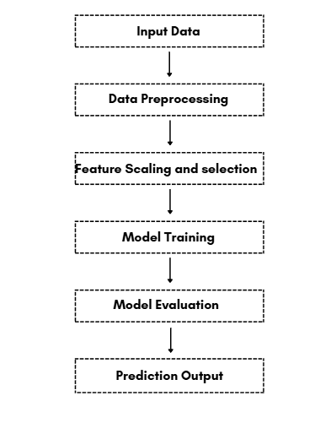

- Expected Modules/ Libraries to be used :
- NumPy: Used for numerical computations and handling arrays efficiently.
- Pandas: Used for data manipulation, cleaning, and preprocessing of datasets.
- Matplotlib / Seaborn: Used for data visualization and plotting graphs.
- Scikit-learn (sklearn): Provides machine learning algorithms like Logistic Regression, KNN, and tools for preprocessing and evaluation.
- StandardScaler: Used for feature scaling to normalize data distribution.
- Expected Evaluation metrics and Plots to be used:
Evaluation Metrics:
- Accuracy: Measures overall correctness of the model.
- Precision: Measures correctness of positive predictions.
- Recall: Measures how well the model identifies actual positive cases.
- F1-Score: Harmonic mean of precision and recall for balanced evaluation.
Visualization Plots:
- Confusion Matrix (to visualize classification performance)
- ROC Curve (to evaluate classification threshold performance)
- Feature Importance Graphs

- Required topics from the subject:
- Data Preprocessing:
Involves cleaning data, handling missing values, and preparing the dataset for training.
- Feature Scaling (Standardization):
Ensures all features contribute equally by bringing them to a common scale.
- Machine Learning Algorithms:
Logistic Regression and KNN are used for classification tasks.
- Model Evaluation Techniques:
Metrics like accuracy, precision, recall, and F1-score are used to measure performance.
- Data Visualization:
Graphs and plots help in understanding patterns and model results.
- Platform Required:
Visual studio/ jupyter notebook
- Books and Link Sources:
- Hands-On Machine Learning with Scikit-Learn and TensorFlow – Aurélien Géron
- Introduction to Machine Learning with Python – Andreas C. Müller
- Scikit-learn Official Documentation: https://scikit-learn.org
- Kaggle Datasets: https://www.kaggle.com
- Python Documentation: https://docs.python.org

Prompt used for Dataset:
Now generate a dataset with these columns , generate 200000 rows , add null values, inject 5% outliers . AGE, BP, CHOLESTROL(numerical) gender (M/F), bmi(number) , family history of heart disease(yes/no), smoking status (smoker/non-smoker), alcohol consumption(no/yes) , physical activity (low/medium high),stress level (1-10), sleep hours(3-10) , diabetes(yes/no) , hypertension (yes/no)

